Assignment-1: write a html code to display following text in the browser?

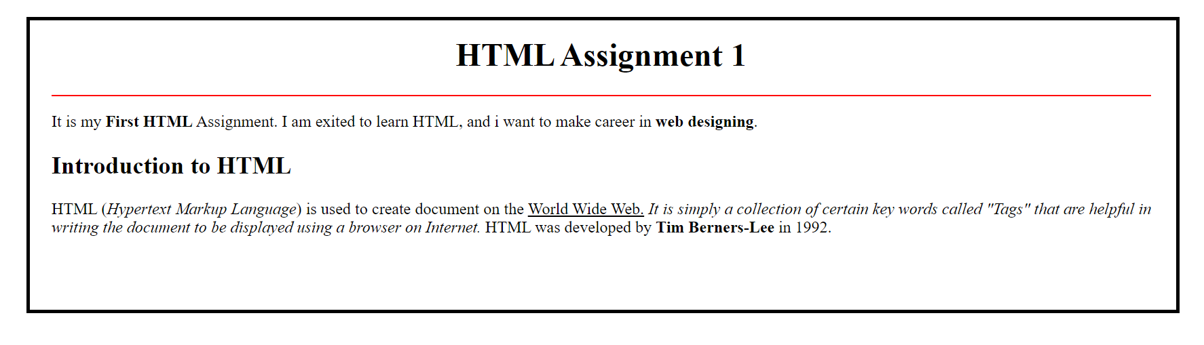

Assignment-2: write a html code to display following text in the browser?



Assignment3: write a html code to display following text in the browser

